**CHAPTER ONE**

**INTRODUCTION**

**1.1 Overview**

|  |
| --- |
| This chapter gives an overall [review](https://explorable.com/what-is-a-literature-review) of the project; the use of Information and Communication Technology in administering examinations can improve efficiency and reduce the delay in the notification of a student’s score after examination. A Computer Based Examination System (CBES) was designed to reduce the delay in the notification of student’s final examination score as well as other aspects of assessment such as Test and Assignments. The examination result processing presents a notification of the student’s final score in an examination as well as scores in other forms of assessments. The use of CBES can improve the efficiency as it consumes less time for result processing and profitability of academic institutions as it reduces the cost of stationeries and labor involved in conducting examination manually. This work can be improved through the introduction of other forms of questions types; such as theory based and diagrammatic questions to make the test questions more diverse. |

**1.2 Background of the Study**

An Examination is one of the best methods of evaluating the knowledge and ability of an individual (Adebayo &Abdulhamid, 2014). Its purpose is to assess how much each student has learned compared to fellow students in the same course or learning situation(Ombudsperson, 2006).Various examination methods are being used in higher education institutions to assess academic progress, such as paper-pencil-based examinations, assignments, presentations, etc. These methods are referred to as traditional methods.

Traditional Examination refers to a formal examination administered through question papers to which students respond in the form of written answers to a limited choice of previously unseen examination questions, set in advance and answered in examination centers where invigilators (examination supervisors) prevent communication between students and prohibit the use of notes or other revision aids (Harris, 2005).

The paper and pen method of writing examination, which has been in existence for decades, may not be fascinating for use because of the problems usually experienced, which include delay in the release of results, examination malpractices, cost implication of printing examination materials and human error(Fagbola, Adigun & Oke, 2013).

Students’ performance improved dramatically when they were not required to scroll through the question paper, because, the students may be disadvantaged by the introduction of online assessment, unless care is taken with the student assessment interface,(Ricketts &Wilks, 2001).

The introduction of online assessment resulted in a drop in student performance between two cohorts of students, a few students felt that online examinations were more stressful or had disadvantaged them, because they hate computers (Ricketts &Wilks, 2001).

The shift of examination as well as examination administration procedures from paper-based to information technology based processes necessitates substantial reorganization processes at universities. Administrative staff, IT support staff, lecturers and examiners as well as students have to adapt to and familiarize themselves with new examination practices known as online examination (Bauer, 2008).

Meanwhile Information-Communication Technology (ICT) offers so many outstanding possibilities for teaching and learning that its application has been growing steadily in every segment of education (Thomas, 2008).

In addition, technology offers new assessment methods that cannot be otherwise realized. It is without doubt that TBA will replace paper-based testing in most of the traditional assessment scenarios, and technology will further extend the territories of assessment in education, as it provides frequent and precise feedback for the participants in learning and teaching that cannot be achieved by any other means (Lei, 2006).

Computer Based Examination (CBE) fully represents Computer Base Assessment (CBA) and Technology Based Assessment (TBA) and an overview of the historical background of the early 2000s, much has occurred in CBE.

**1.2 Problem Statement**

The paper and pen (manual) method of writing examination, which has been in existence for decades, may not be fascinating for use because of the problems usually experienced, which include examination venue capacity constraints, lack of comfort for examination candidates, delay in the release of results, examination malpractices, cost implication of printing examination materials and human error (Fagbola et. al, 2013).

**1.3 Research Questions**

1. What effect has delay in registration and the release of results had on candidates?
2. What is the impact of human error in examination system?

**1.4 Research Objectives**

The objectives of this project are:

1. To design a computer based examination system with real time processing of results for candidates.
2. To develop a computer based examination system with enhanced security features to avoid exam malpractice, human errors and accurate result processing.

**1.5 The Scope of the Study**

The project is mainly on examination system that allows students’ register and seat for examination and processes their result in real-time.

* 1. **Significance of the Study**

Hence this project will make a huge difference to what has been in existence and thereby add to the body of knowledge. Computer Based Examination with result processing would process examination results in real time, curb examination malpractices and human error to enhance effectiveness and reduce the cost implication of printing examination materials and the waste of resources and enhance need to follow the technological trend in examination.

**CHAPTER TWO**

**LITERATURE REVIEW**

* 1. **Preamble**

Literature Review entails to examine the critical points of past and current knowledge in a particular field of study. This chapter entails summary and critical analysis of relevant researches available, which includes findings and contribution to the topic “Design and Implementation of Compute Based Testing”.

**2.2 Review of Related Literature**

A research carried out by Sadiq and Onianwa (2011), noted that the predominant mode of student’s assessment in Nigeria is the traditional method. In this method, students are assessed using paper and pen on cognitive abilities. This method of assessment has imposed serious limitations to the effectiveness of the method. E-examination can be used to assess cognitive and practical abilities. Cognitive abilities are assessed using e-testing software; practical abilities are assessed using e-portfolios or simulation software.

Alabi, Issa and Oyekunle (2012) corroborated this by identifying the Paper & Pen Test (PPT) with many problems such as: Tedious processes as the examination is conducted at various and distant centers simultaneously and marked manually; high risks of accidents during travels by both the staff involved and the prospective students for the paper examination; cost of conduct of the examination on the part of the examination bodies including honoraria for invigilators, coordinators, markers collators and other allied staff; subjective scoring and plausible manipulation of results; late release of results and missing grades; bank draft method of payment by candidates riddled by fraud, loss of money, stress and trauma.

Meanwhile, according to Balogun (1995), examination should be the true test of the knowledge gained in any educational institution, but the approach that is being used to set, work and manage this test of knowledge has made it relatively uncertain that examination is a true test of knowledge.

More so, in effort to get rid of examination malpractice in Nigerian institutions JAMB introduces Computer-Based Test as of 2013.   For JAMB, the reasons adduced for adopting CBT in the conduct of UTME is that it would completely curb examination malpractices as well as eliminate result blackout. However, some of the challenges the Computer Based Test (CBT) had were cases where candidates before the commencement of examination would copy supposed answers from their cell phones into small sheets of papers, which they hide in secluded parts of their body including their private parts to beat security officers. But the system did not feature instant result publication.

Meanwhile, Ayo (2007), proposed a model for electronic examination in Nigeria which enforces all applicants to be subjected to online entrance examination as a way of curbing the irregularities as in the Joint Admissions Matriculation Board (JAMB) examinations. This model was designed and tested in Covenant University, one of the private universities in Nigeria. Findings revealed that the system has the potential to eliminate some of the problems that are associated with the traditional methods of examination such as impersonation and other forms of examination malpractices.

However, Akinsanmi *et al* (2010), developed a web application where tests in multiple choice formats could be taken online and graded immediately. The web application relies solely on Microsoft developed technologies. It runs on the Microsoft.net framework, uses the ASP.NET web server, C# as the intermediate language, ADO.NET to interact with the relational database and Microsoft SQL server as the relational database.

Similarly, Rashad *et al* (2010), developed an online examination system that carry out the examination and automatic grading for student’s examinations. The system facilitates conducting examinations, collection of answers, automatically marking the submissions and production of reports for the test. It supports many kinds of questions. It was used via Internet and also suitable for both local and remote examination. The system could help lecturers, instructors, teachers and others who are willing to create new examinations or edit existing ones as well as students participating in the examinations. The system was built using various open source technologies such as PHP, HTML and MYSQL database engine. An automatic grading module was developed to incorporate different examination and question types. The system was tested in the Mansoura University Quality Assurance Center. The test proved the validity of using this kind of web based systems for evaluating students in the institutions with high rate of students.

However, the limitations of the above systems are enormous: these systems are domain/application area-specific, so cannot fit into all deployment area needs; not well secured in terms of data security and integrity; do not present a generalized model for adoption by any user willing to migrate to the *e*-examination platform; most of the systems are stand-alone applications that only run on distributed networks and thus access is limited to the networked geographical domain. However, in this project, these limitations are well addressed.

**2.2.1 Features of a CBES**

A CBES is a form of assessment in which the computer is an integral part of question papers’ delivery, response storage, marking of response or reporting of results from a test or exercise (Whittington et al, 2000).

It can be a multiple choice question based examination system that provides an easy to use environment for both Test Conductors and Students appearing for Examination. The main objective of a CBES is to provide all the features that an Examination System must have, with the interfaces that do not scare its users (Baddi, 2010).

According to Taylor (2005) as cited in Newhouse (2013), a Computer-Based Testing could be delivered on a stand-alone personal computer, within an isolated Local Area Network (LAN) or through the use of online technologies such as web-pages over the Internet. The two types of CBES are:

1. Linear Test - This involves a full-length examination in which the computer selects different questions for individuals without considering their performance level.
2. Adaptive Test - Here the computer selects the range of questions based on individuals‟ performance level. These questions are taken from a very large pool of possible questions categorized by content and difficulty (Alabi et al, 2012).

**2.2.2 Effectiveness of a CBES**

The effectiveness of a computer based testing system depends largely on factors such as standardization, security, examination conditions, mode of administering the examination, cost and so on. Some of these factors have been identified in literature as follow:

1. A CBES is cost effective especially when deployed in the conduct of a mass-driven examination as there will be no need to print questions or answer booklets (Fagbola et al, 2013).
2. Adewale et al (2010), inferred that human errors can be eliminated and examination malpractice eradicated when a CBES is adopted in the process of examination. In the same vein, Akunyili (2010) in her presentation in Amsterdam on ‘ICT and E-government’ stated that manually marked scripts were more prone to errors than computer marked ones.
3. In their system design, Adebayo et al (2014) stated that security will be more effective since the system includes biometric fingerprint authentication, picture capture and data encryption and decryption.
4. Al-Amri (2007) also stated that the standardization of test administration conditions is one of the benefits offered by CBES. No matter the size of the test-takers, CBES helps test developers to set the same test conditions for all participants.
5. Bodmann and Robinson (2004) in their study investigated the effect of several different modes of test administration on scores and completion times. They observed that undergraduate students completed the computer-based assessment test faster than the paper-based assessment test.
6. Jamila et al (2012) presented that technology based assessment provide opportunities to measure complex form of knowledge and reasoning that is not possible to engage and assess through traditional methods.
7. Osang (2012) in his study of electronic examination in Nigeria, suggested that course coordinators prefer electronic examination to pen and paper examinations as it requires lesser administrative tasks for the coordinators and enhances a timely release of examination result.

**2.2.3 Applications of CBES in Nigeria**

Online examinations which are a variant of a CBES can be used as an assessment-evaluation tool in distance education systems that have quite a number of students. For such systems, good execution of examination aimed at assessment and evaluation is very critical because problems arising from human-centered errors or technical difficulties may lead to questioning of the examination, and thus reliability and efficiency of the distance education systems (Taşci et al, 2014).

Resuscitated in 2002 by President Olusegun Obasanjo, National Open University of Nigeria (NOUN) (a distance learning institution) which currently has not less than seven schools and academic centers employs the use of electronic examination in the evaluation phase of students study circle. Research studied on 105 academic staff revealed that 84 respondents recommended CBES for conducting examination in NOUN based on the fact that it was easy to administer and used by the students. Most especially is the fact that, the result of the examination can be viewed almost immediately after the examination (Osang, 2012).

Tertiary institutions in Nigeria now use CBES in the Post Unified Tertiary and Matriculation Examination (Post-UTME) for screening their students. Also, some Nigerian universities are almost fully or partially implementing the CBES for assessing their students. These include:

1. National Open University of Nigeria (NOUN)
2. University of Ilorin, Ilorin
3. Federal University of Technology, Minna
4. Covenant University, Ota (Private)
5. University of Nigeria, Nsukka
6. University of Lagos, Lagos

However, NOUN is the only Nigerian University that is fully implementing CBES for assessing her students and this is employed through the internet. Other universities employ the use of the Intranet (Adegbija et al, 2012). Furthermore, the Joint Admissions and Matriculation Board (JAMB) which is the national matriculation examination body for admissions into Nigerian higher institutions of learning has adopted the use of a CBES for the conduct of its examination.

The revolutionary dimensions of this ICT-enhanced service can only be appreciated when compared with the former system where the examination results were anxiously awaited by the candidates for close to eight weeks as against seven working days with the use of a CBES (Kunyili, 2010).

**2.1.4 Examination Malpractice**

Annam, (2010) viewed examination malpractice as the greatest problem of a manual examination system. To start with, examination malpractice has lead to fallen education standards in almost all the countries in Africa Yakubu (1998), Olumero (1992), Harcout et al, 1997). It has become institutionalized, involving students, lecturers, and non-academic staff (Annam, 2010; Edokpa, 1998; Abdulkareem and Alabi, 2004). It has become a business operated by a Mafia leading to serious dangers to those who wants to stop the benefactors of these business from continues profit while unfortunately, our schools are living in a state of denial (Enne and Ursula, 1998; Balogun (1999); Oladunni, 1995; Annam, 2010; Adegboye, 1998). Yakubu, (1998) and Edokpa, (1998), described examination malpractice as a cankerworm.

The history of examination malpractice can be dated before 1977, since in the early 70s mass cheating was first perpetrated in WAEC examination (Ojikutu, 1987). It has become a national problem starting from primary schools to tertiary institutions (Ezema, 2001; Eweniyi, 2002; Abdulkareem and Alabi, 2004; Oredein, 2004). Abdulakareem and Alabi (2004) explained that examination malpractice is as old as examination itself but however the rate at which examination malpractice occurs in the educational system in recent time is highly disturbing. It therefore needs prompt attention by all stakeholders.

**2.1.5 Causes of Examination Malpractice**

According to a research submitted at Mariam Babangida Girls Science College,Minna, by an SS III student Aisha (2010) titled “Examination Malpractices: Causes, Effects and Solutions” Examination malpractice is a cankerworm that portends grave dangers for the nation. However, the major causes of examination malpractice are:

1. Laziness of Students: Seriousness is thrown to the wind by many students. Most of them have little time for their studies. They spend their time attending parties and forming gangs who engage in untoward behaviour.
2. Second is large population of students in many schools. The few who do very well may be promoted or admitted into higher institutions. Students cheat therefore to excel over their mates.
3. Many students are desperate; thinking that passing examination is a do or die affair. They want to excel by all means. Some want promises from parents fulfilled. Others want to be on TV or Newspapers as the best in one form of examination or the other (though cheating hardly excel).
4. Syllabus in many subjects such as Physics, Chemistry, etc is wide and difficult for teachers to cover.
5. Another cause of examination malpractice is inadequate preparation for exams. In a number of schools, the teachers are few and specialized ones are fewer so students are not adequately prepared for the examinations.
6. Corrupt invigilators and supervisors: The students know if they offer bribe to the invigilators, they will allowed to cheats in the examination hall.
7. Lastly, there is a general trend in our society towards cheating and this is encouraged by almost all members of the population.

The evil effect of examination malpractice cannot be overemphasized. Creativity and resourcefulness are hampered. It wreaks great havoc on the social, religion, economic and political lives of Nigerian. Employees are engaged in jobs they are not suited for since the certificates they claim to possess are not merited.

**2.1.5 Incidence and Forms of Examination Malpractice**

According to research carried out by Ijaiya (2004), examination malpractice takes different forms. The following list is not exhaustive, but the major ones had been identified by the following:

1. Collusion
2. Impersonation
3. Smuggling of answer scripts
4. Examination leakage
5. Mass cheating
6. Insult/assault on Examination Officials
7. Irregular activities inside and outside the examination hall
8. Expo
9. Contractor
10. Dubbing
11. Super Print
12. Bullet or Missiles
13. Microchips
14. Hi-tech Micro Computer
15. Networking
16. Refusal to submit answer script at the end of the examination.

**2.1.6 Computerize Test Taking, Marking and Results Publication**

In the early 1990s administrators of standardized tests began offering computerized examinations. Computerized tests adapt to the skill level of the individual test-taker. Each correct answer given by a student is followed by a more difficult question, and incorrect answers are followed by less difficult questions. The more difficult the question, the more points the student can score. Besides adjusting questions to a student’s performance level, the computerized test calculates an immediate score and allows students to instantly transmit results to institutions of their choice (Carlo, 2007; Encarta, 2009).

Carlo, (2008) defined a computerized test as the use of computers to deliver, mark and analyze examinations. While this definition is wide enough to cover both restricted responses and supply items it also explains in brief what these tests are. For restricted response items, such as multiple choice examinations, structural response questions, distracters and correct answers as well as feedback can be predefined. These examinations were used for both formative and summative purposes, and once setup, can be used by student independent of teacher’s involvement.

According to Carlo (2008), Computer Assisted Assessment(CAA) tools for this type of assessment are readily available, yet barriers still exists regarding the time required to master the tools, the skills needed to write good assessment. While computers are excellent at judging restricted response questions, they perform very well when the answers are supplied by students in a word or two but not exceeding five words. The computerized way of accessing examination has over the years served as a bridge between the erroneous result produced by the manual approach and the desired result of any examination grading system.

Burstein *et al*, (2004) assessment should be student centered to enable meaningful and relevant learning experience. Meaningful and constructive assessment need to challenge students to think critically and should encourage students learning and directs student effort. The true test of knowledge gave birth to the writing of examination and the accurate test of this knowledge has given birth to an automated way of testing, marking and publishing examination (Burstein *et al*., 2003).

**CHAPTER THREE**

**METHODOLOGY AND DESIGN**

**3.0 Preamble**

Research methodology is a careful study or investigation, especially in order to discover new fact or information, that is, the method used by the researcher to collect data or information; hence, research methodology should be sound enough to make attainment of the set objectives possible with specific components such as phases, tasks, methods. Techniques and tools can also be defined as the analysis of the principle of methods, rules and postulates employed by a discipline. This chapter entails the input and output specifications for the design and implementation of computer based test, use case and activity diagram as well as the system requirement.

**3.1 Method of Data Collection**

There are different methods of data collection but the method of data collection used in this project work is Documentation Method.

Documentation method is a secondary method of data collection. This method involves the use of journals, handbooks, newspapers and projects. This method of data collection was used because it serves as a basis of reference to existing research work. These include: Internet, Past Projects and text books.

**3.2 System Modeling**

System Modeling can be done using several modeling language, but in this project work, the Unified Modeling Language (UML) is used.

* + 1. **Use Case Diagram**

Use Cases are services or functions provided by the system to its users and to identify the primary elements and processes that form the system. The primary elements are termed as “actors” and the processes are called “Use cases”. The Use Case diagram shows which actors interact with each use case and the purpose of a Use Case diagram is to provide a graphical view of the functionality provided by the system in terms of actors, goals of actors (represented as Use cases) and dependencies between Use cases.

Login

Log-out

Add Course /Questions

EditCourse / Questions

Save course / Questions

Take Test

Add New Student

View Results

Validate details

Maintenance

Student

Admin

**Fig. 3.1**:**Use case Diagram Showing the System**

**3.2.2 Activity Diagram**

An activity diagram illustrates the dynamic nature of a system by modeling the flow of control from activity to activity. An activity represents an operation on some class in the system that results in a change in the state of the system. Typically, activity diagrams are used to model workflow or business processes and internal operations. Because an activity diagram is a special kind of state chart diagram, it uses some of the same modeling conventions.



**Figure 3.2: New Entry (Student, Course & Question) Activity Diagram**

Edit Details Entered

Cancel

Save

Close Database

Open Database

Accept ID

Display Details

Invalid?

Valid

**Figure 3.3: Edit (Student, Course, Question) Activity Diagram**

Accept Id

Confirm Deletion

Cancel Deletion

Valid

Open Database

Close Database

Proceed with deletion

Delete Record

**Figure 3.4: Delete (Student, Course & Question) Activity Diagram**



**Fig 3.5: Exams Activity Diagram**

**3.3.3 Class Diagram**

This is an illustration of the relationship and source code dependencies among classes in the unified modeling language (UML). In this content, a class defines the methods and variables in an object, which is a specific entity in a program or the unit of code representing that entity.



**Figure 3.6**: **Class Diagram**

**3.4 DATABASE DESIGN**

A database is a collection of information that is organized so that it can be easily accessed, managed and updated.

**3.5 INPUT SPECIFICATION**

Input specification is the logical presentation of how data is stored in the computer’s memory. The input specification used in this project work is presented below:

**Table 3.1 Name: Login**

|  |  |  |  |
| --- | --- | --- | --- |
| **FIELD NAME** | **DATA TYPE** | **LENGTH** | **DESCRIPTION** |
| Username | Character | 10 | Username |
| Password | Character | 15 | Access code |

Primary key: Password

**Table 3.2 Name: Student Registration**

|  |  |  |
| --- | --- | --- |
| **FIELD NAME** | **DATA TYPE** | **DESCRIPTION** |
| RegNo | int (11) | Registration No. |
| Firstname | varchar (25) | First name |
| Middlename | varchar (25) | Middle name |
| Surname | varchar (25) | Surname |
| Address | varchar (50) | Address |
| DateofBirth | varchar (10) | Date of birth |
| Gender | varchar (6) | Gender |
| Phone | varchar (11) | Phone No |
| EmailAddress | varchar (100) | Email Address |

Primary key: RegNo

**Table 3.3 Name: Course**

|  |  |  |
| --- | --- | --- |
| **FIELD** | **TYPE** | **DESCRIPTION** |
| Course id | varchar (5) | Course ID |
| Course Name | varchar (6) | Course Name |

**Table 3.4 Name: Question**

|  |  |  |
| --- | --- | --- |
| **FIELD** | **TYPE** | **DESCRIPTION** |
| QuestionId | int (5) | Question ID |
| CourseId | varchar (10) | Subject ID |
| Option 1 | varchar (75) | Answer one |
| Option 2 | varchar (75) | Answer Two |
| Option 3 | varchar (75) | Answer Three |
| Option 4 | varchar (75) | Answer Four |
| Answer | varchar (100) | Correct answer |

Primary key: QuestionId Foreign key: courseId

**Table 3.5 Name: Exam**

|  |  |  |
| --- | --- | --- |
| **FIELD** | **TYPE** | **DESCRIPTION** |
| Exam – id | int (5) | Exam Id |
| Reg. No. | varchar(20) | Registration Number |
| Student Name | varchar(25) | Student Names |
| Course | varchar(20) | Course Taken |
| Score | int(3) | Score in a course |
| Grade | varchar (2) | Grade in a course |

Primary key: RegNo

* 1. **Output Specification**

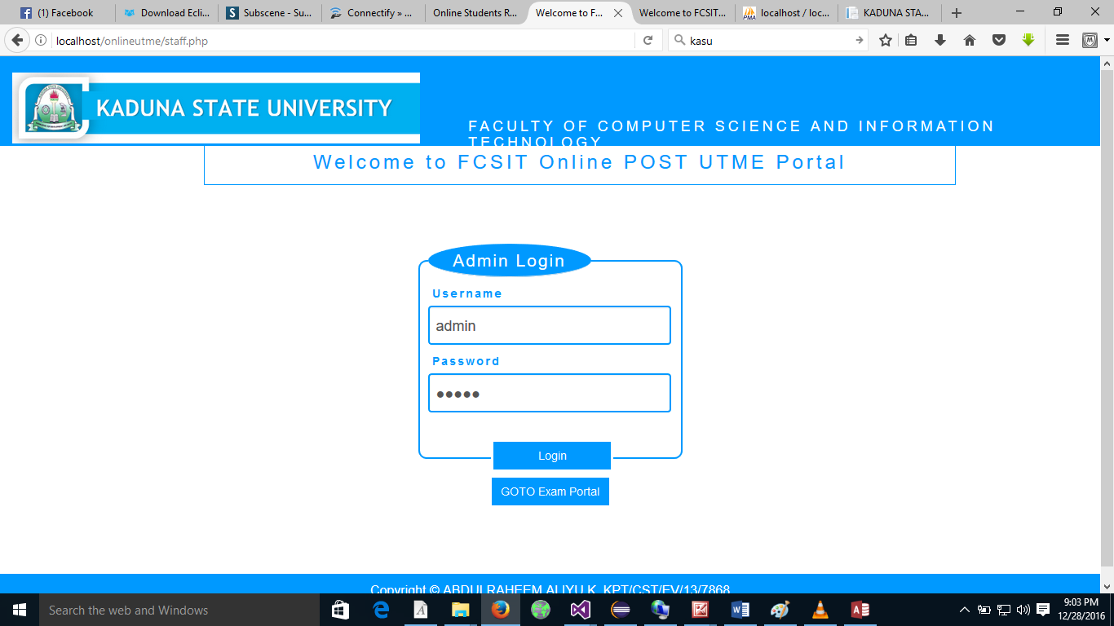This declares and show the result obtained from the input specified. Below is the output specification.

**Figure 3.7: Login**

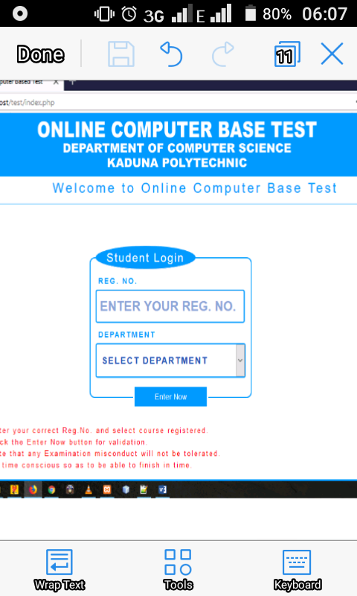

**Figure 3.8: Student Login**

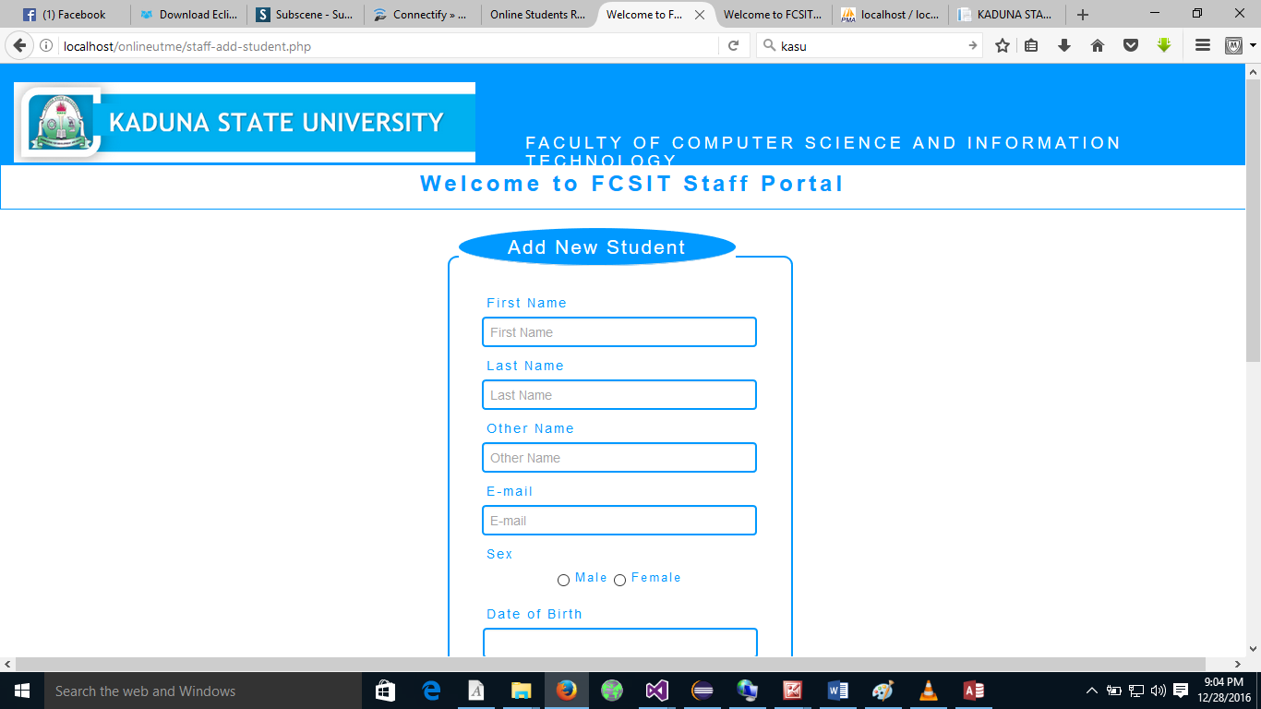

ADD STUDENT

CLOSE

**Figure 3.9 New Student Registration**

ADD COURSE

Course ID

Course Name

Course Description

SAVE

CANCEL

**Figure 3.10: Add Course**

=====Select===

Question ID:

Course:

**ADD QUESTION**

Option 1

Option 2

Option 3

Option 4

Correct answer

Save

Cancel

**Figure 3.11: Add Question**

Logout Welcome: Logout Time:00:00:00

Selected Course

Question 1

A.

B

C

D

Option 1

Option 2

Option 3

Option 4

<<

NEXT >>

FINISH

**Figure 3.12: Test Screen**

**COMPUTER BASED TEST FOR DEPARTMENT COMPUTER SCIENCE**

**REPORT**

**REG. NO FULLNAME GENDER PHONE COURSE SCORE GRADE**

**99999 XXXXXXXX XXXXX 99999 XXXXX 9999 XX**

**99999 XXXXXXXX XXXXX 99999 XXXXX 9999 XX**

**99999 XXXXXXXX XXXXX 99999 XXXXX 9999 XX**

**Figure 3.13: Results**

**3.7 System Requirements**

System requirement is a combination of hardware and software components that makes work to be carried out. The system requirement for this research work is subdivided into Hardware and Software requirements.

**3.7.1 Hardware Requirements**

Hardware is the computer equipment and devices that are involved in the function of a computer system together with the software components. Hardware are the physical components of the computer system assembled together to interact with the software in order to form a composite system.

The minimum hardware requirements are:

1. CPU Core i3 processor
2. 100MB available disks space
3. RAM (1 GB)
4. Keyboard
5. Mouse
6. 14’SVGA Colored Monitor
7. U.P.S 650va (uninterruptible power supply)
8. Hard Disk Drive (HDD) of 60GB
   * 1. **Software Requirements**

Software is set of program modules needed to control and co-ordinate the activities of the hardware device of the computer system.

The following are software’s required for the system to function:

1. Operating System (O/S) – Windows XP or higher version
2. Xampp

**3.8 Choice of Programming Language**

This project is designed using PHP as the programming language for the front-end while MySQL is used for the design of the database (back-end). PHP is the web development language written by and for web developers. PHP stands for Hypertext Pre-processor. It is a robust, server-side, open source scripting language that is extremely flexible and very easy to learn.